WEEK 12

Question 1:

4th Bit

Problem Statement:

A binary number is a combination of 1s and 0s. Its nth least significant digit is the nth digit

starting from the right starting with 1. Given a decimal number, convert it to binary and

determine the value of the the 4th least significant digit.

Example

number = 23

• Convert the decimal number 23 to binary number: 2310 = 24 + 22 + 21 + 20 =

(10111)2.

• The value of the 4th index from the right in the binary representation is 0.

Function Description

Complete the function fourthBit in the editor below.

fourthBit has the following parameter(s):

int number: a decimal integer

Returns:

int: an integer 0 or 1 matching the 4th least significant digit in the binary

representation of number.

Constraints

0 ≤ number < 231

Input Format for Custom Testing

Input from stdin will be processed as follows and passed to the function.

The only line contains an integer, number.

Sample Input

STDIN Function

----- --------

32 → number = 32

Sample Output

0

Explanation

• Convert the decimal number 32 to binary number: 3210 = (100000)2.

• The value of the 4th index from the right in the binary representation is 0

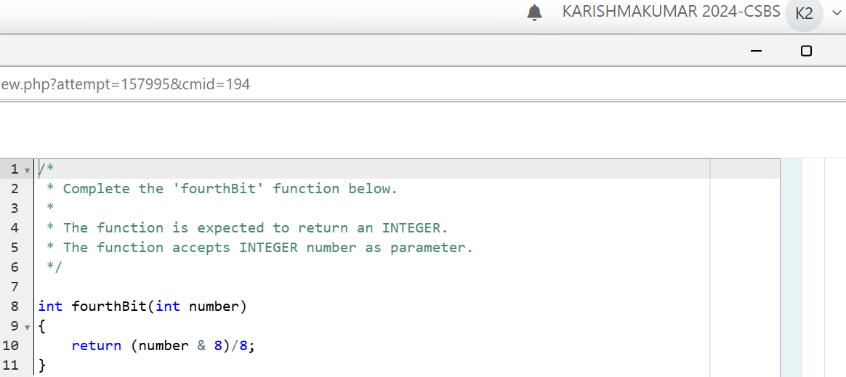

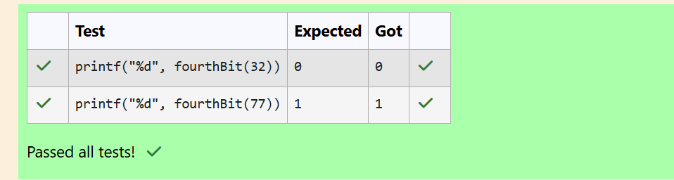

Question 2:

The Power Sum

Problem Statement:

Find the number of ways that a given integer, X, can be expressed as the sum of the Nth

powers of unique, natural numbers.

For example, if X = 13 and N = 2, we have to find all combinations of unique squares adding

up to 13. The only solution is 22 + 32.

Function Description

Complete the powerSum function in the editor below. It should return an integer

that represents the number of possible combinations.

powerSum has the following parameter(s):

X: the integer to sum to

N: the integer power to raise numbers to

Input Format

The first line contains an integer X.

The second line contains an integer N.

Constraints

1 ≤ X ≤ 1000

2 ≤ N ≤ 10

Output Format

Output a single integer, the number of possible combinations calculated.

Sample Input

10

2

Sample Output

1

Explanation

If X = 10 and N = 2, we need to find the number of ways that 10 can be represented as the

sum of squares of unique numbers.

10 = 12 + 32

This is the only way in which 10 can be expressed as the sum of unique squares

